Goal:
Use the classes and methods provided by JPA to reduce the burden of writing codes for relational object management

Libs:
Javax.persistence

Relationship of the classes in the .jar:
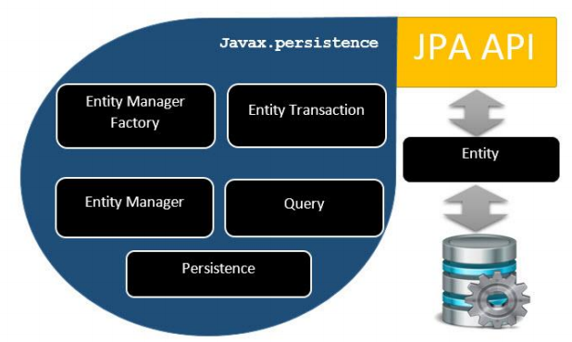

Comment:
This spec doc will be updated every time i find something new about it

